|  |
| --- |
| **Title :To calculate time period of pendulum and display it on LCD** |
|  |
| ***DE Lab Project Report*** |
| ***Submitted By*** |
| **1.SHWETA SHARMA (18BCS4585)**  **2.SAMEKSHA PANDHI (18BCS4592)**  **3.SAHIL ANAND (18BCS4596)** |
| ***Under the Guidance of*** |
| **Mr. Anshul Sharma**  **Mr. Divneet Singh Kapoor**  **Mr. Khushal Thakur** |
| **Assistant Professors, Academic Unit – 1** |
|  |
| **Academic Unit-1**  **Chandigarh University** |

**Table of Contents**

1. Problem Identification .......................................................................................................... 1

2. Features................................................................................................................................. 2

3. Design Flow ......................................................................................................................... 3

4. Outcome ............................................................................................................................... 4

5. Cost Analysis ........................................................................................................................ 6

6. Product Catalogue ................................................................................................................ 7

**1. Problem Identification**

A **pendulum** is a weight suspended from a pivot so that it can swing freely When a pendulum is displaced sideways from its resting, equilibrium position, it is subject to a restoring force due to gravity that will accelerate it back toward the equilibrium position. When released, the restoring force acting on the pendulum's mass causes it to oscillate about the equilibrium position, swinging back and forth. The time for one complete cycle, a left swing and a right swing, is called the period. The period depends on the length of the pendulum and also to a slight degree on the amplitude, the width of the pendulum's swing.

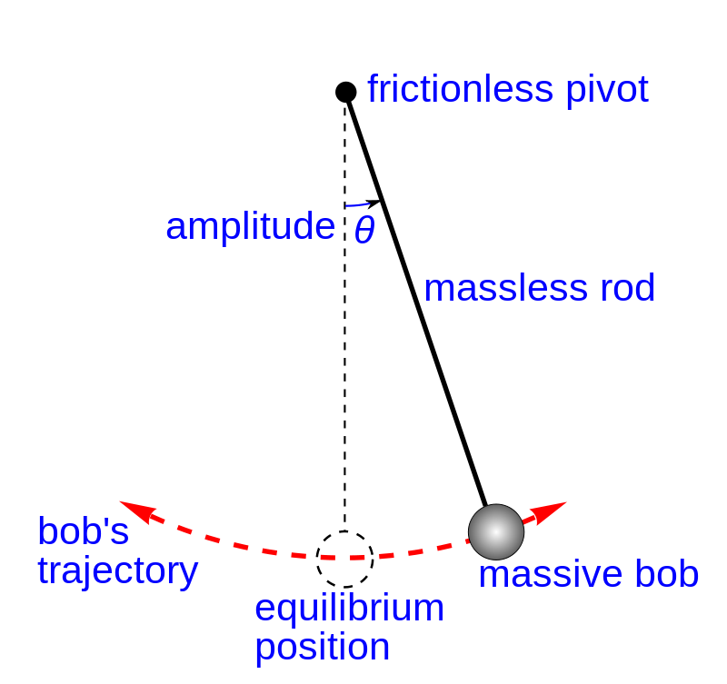

Currently, stopwatch is used in finding the time period of given pendulum which doesn’t give accurate readings of time period. So, to overcome this problem, we have used LED Display which will display the accurate reading .

**2. Features**

*Capabilities of the project:*

*1. Give the accurate time period of the pendulum.*

*2. Concepts are easily cleared by using this project’s idea.*

*3. Easy to understand and operate.*

*Drawbacks of project:*

*1. A little costly than traditional methods.*

*2. Care is needed to handle this project.*

**3. Design Flow**

# Block Diagram-

*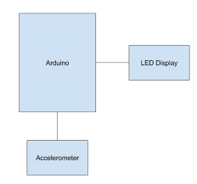*

# Circuit DiagramC:\Users\Abhi\Pictures\20190411_125647.jpg

# Materials

1. Arduino UNO

2. Ultrasonic Sensor

3. Liquid Crystal Display (LCD)

4. Connecting wires

5. Breadboard

# Steps of Circuit Completion

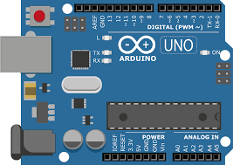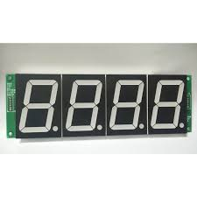

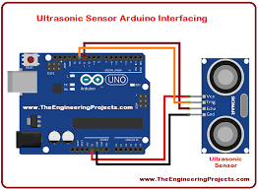

**4. Outcome**

# Steps of Circuit Completion

The time period of pendulum is calculated easily and accurately by the above project.

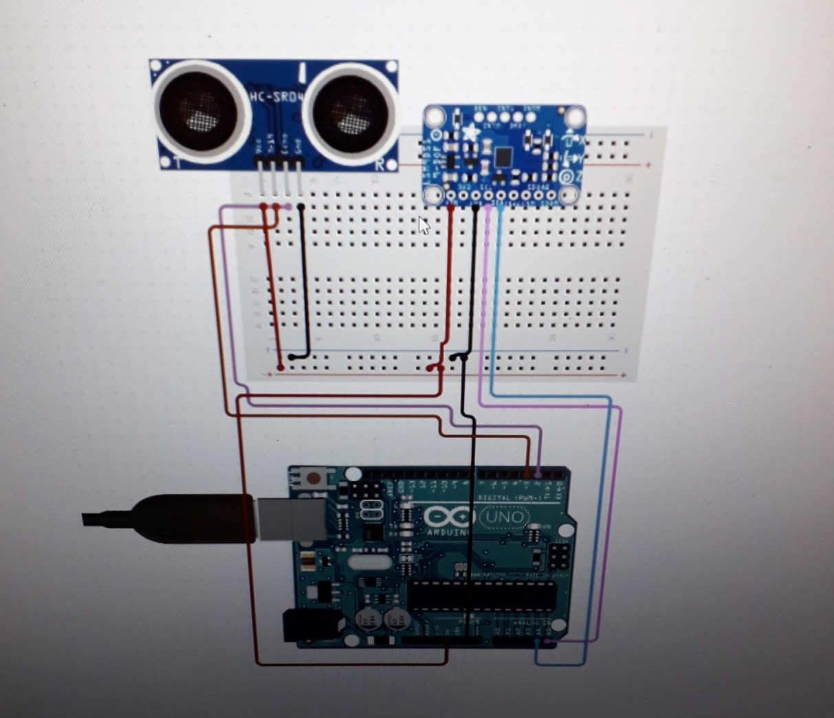

**5. Cost Analysis**

|  |  |  |
| --- | --- | --- |
| **S. No.** | **Component / Material** | **Price (in Rs.)** |
| 1. | Arduino UNO | 450 |
| 2. | Ultrasonic Sensor | 140 |
| 3. | LCD | 200 |
| 4. | Connecting Wires | 80 |
| 6. | Breadboard | 110 |
| **Total** | | 980 |

**6. Reference manual/Lab manual for the designed experiment**

***(to be seFor Govt. funded project only)***

1. Aim : To calculate and display the time period of a pendulum on LCD
2. Components required: A pendulum, LCD, arduino UNO, ultrasonic sensor, connecting wires, breadboard
3. Setup requirements :
4. Procedure for data collection
5. Calculations
6. Observation ( two samples as observation)
7. Result